Table of Contents

Introduction 2

Design 2

Component Diagram 2

User guide 4

Testing 6

Evaluation of the data structure and algorithm 7

Evaluation of the data structure 7

Performance analysis of the data structure 7

Evaluation of the algorithm 8

Performance analysis of the algorithm 8

Appendix 8

Testing Table 8

# Introduction

Purpose of document

This document has come in place to outline

1. Design of the code.
2. User guide for the application.
3. Choice of test data provided.
4. Explanation for the choice of data structure and numerical methods.
5. Reflection.

Goals of Application

* To calculate the probability for the given mean and standard deviation.
* To display a graphical representation of the area of calculated probability.
* To calculate and display the normal distribution table.

# Design

## Component Diagram

The application is divided into five packages to make the code maintainable, easily extendable and reusable.

1. com.nd: This package consists of the main class.

NormalDistributionMain: The application starts from here as it has the main method. This class creates the default user interface.

1. com.nd.ui: This package consists of classes used to create the user interface.

TopFrame: This class sets the title and default closing option of the window.

FormConstatnts: This interface defines the LineBorder of the application.

NormalDistributionGUI: This class has the methods to create GUI components and actionListeners.

1. com.nd.util: This package consists of utility classes.

NDCalculator: This class consists of methods to calculate probability and generate zTable.

NDChartUtil: This class consists of methods for creating graphs. The charts are created using JfreeChart library.

NDValidator: This class consists of methods to validate the data inputs provided by the user.

NDFormUtil: This class is used to add components to the frame.

NDUtil: This class is used to perform conversion of string to double, formatting the result and adding components using GridBagLayout.

1. com.nd.data: This package consists of zTable class.

zTable: This class will populate the z table using a HashMap.

1. com.nd.exceptions: This package consists of InvalidSDException class.

InvalidSDException: This is an exception class for invalid standard deviation. It will be thrown if standard deviation is less than or equal to zero.

# User guide

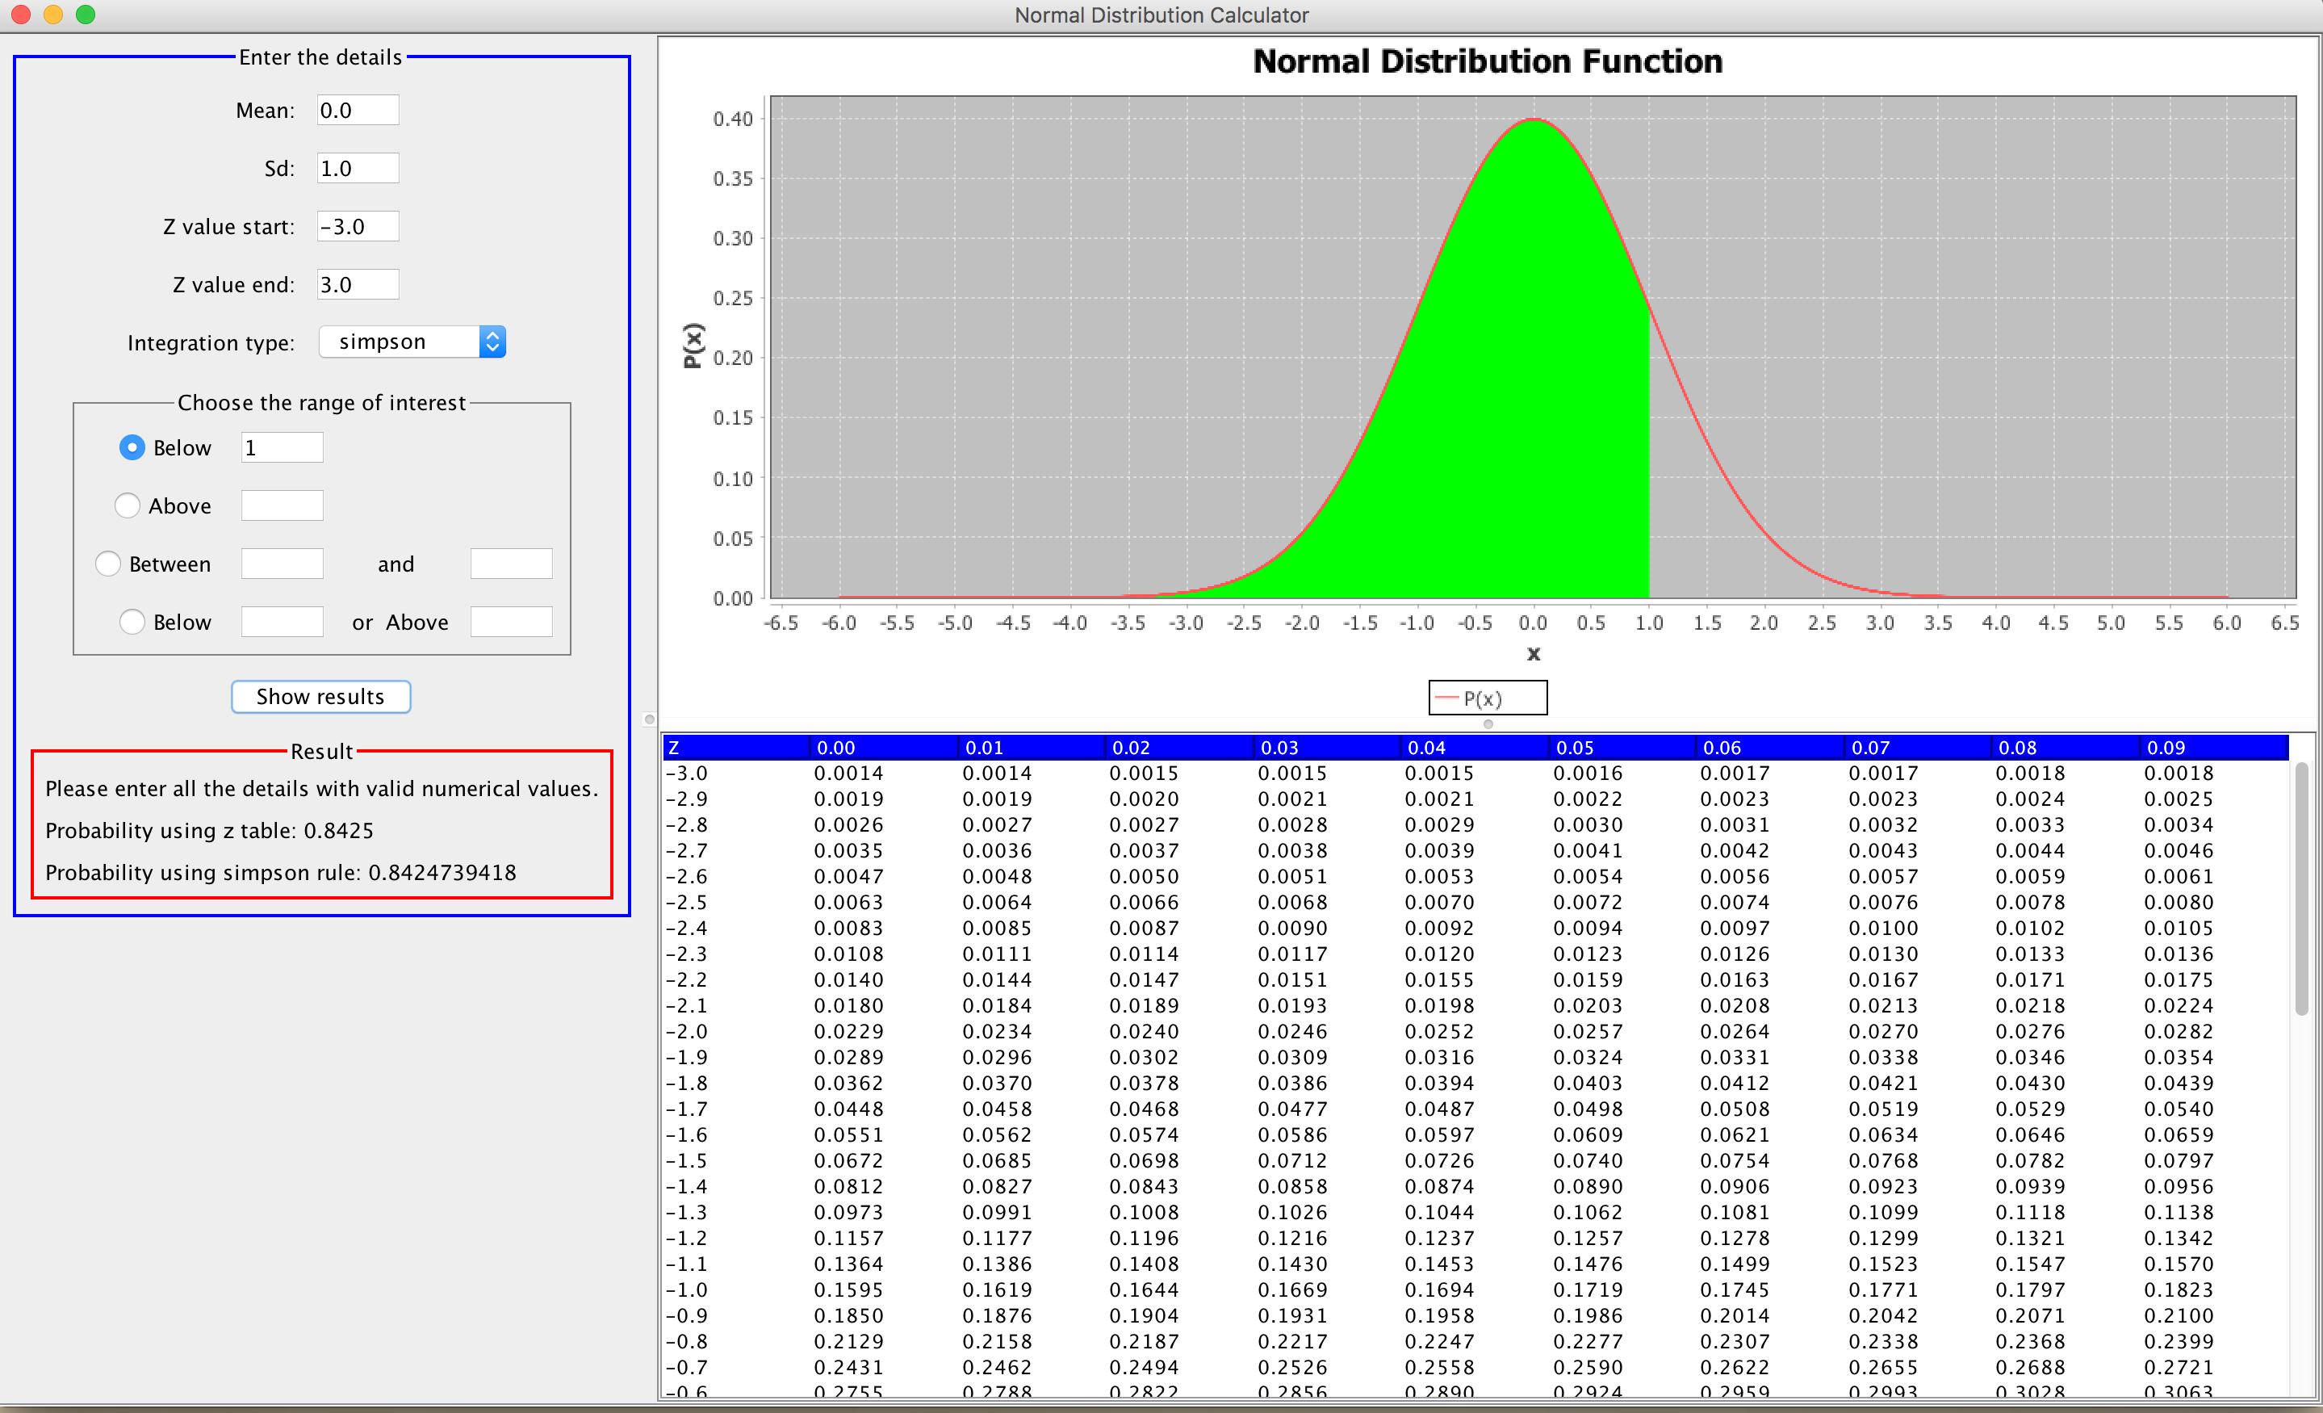The ‘Normal Distribution Calculator’ is an application created for Statistics Group. It is easy to use with a simple input panel. It reports the user if any input is invalid with an error message. The user interface is shown below. It has three sections – input, graph and the z table. This section will provide the guidelines to use the application.

In the input section enter the inputs, choose the desired integration method and scenario. Click the “Show results” button to calculate the result, plot the graph and generate z table.

The four scenarios are below x1, above x1, between x1 and x2 and below x1 or above x2. One of these can be selected by clicking the radio button and inputting the required data. The graph will be plotted according to the scenario chosen.

Figure 1: Below x1

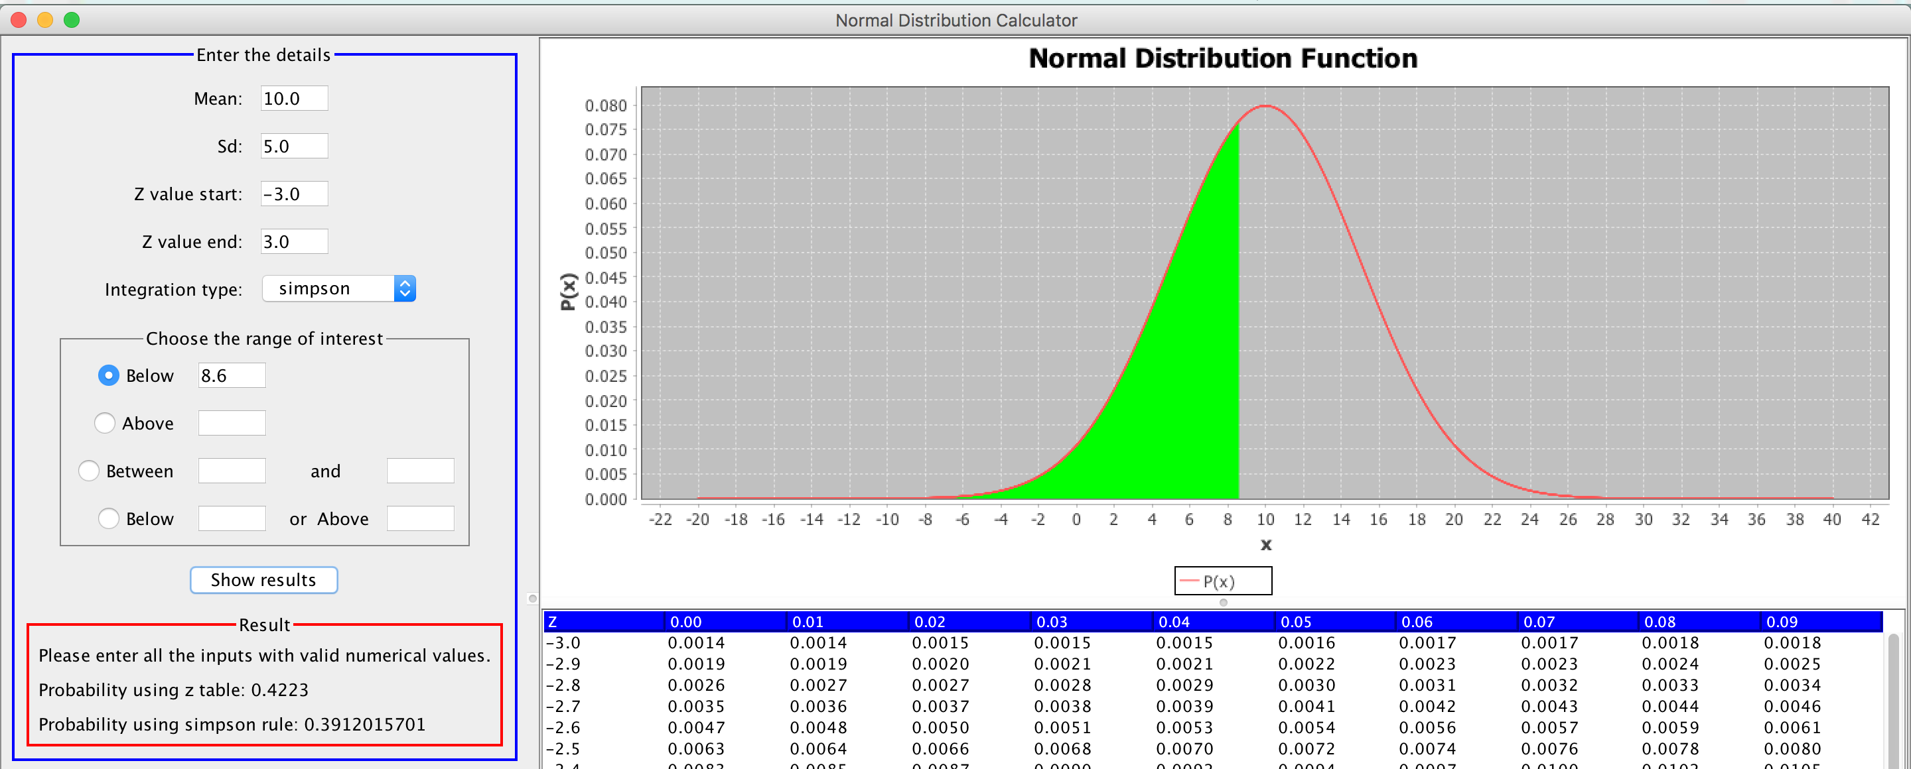

Figure 2: Above x1

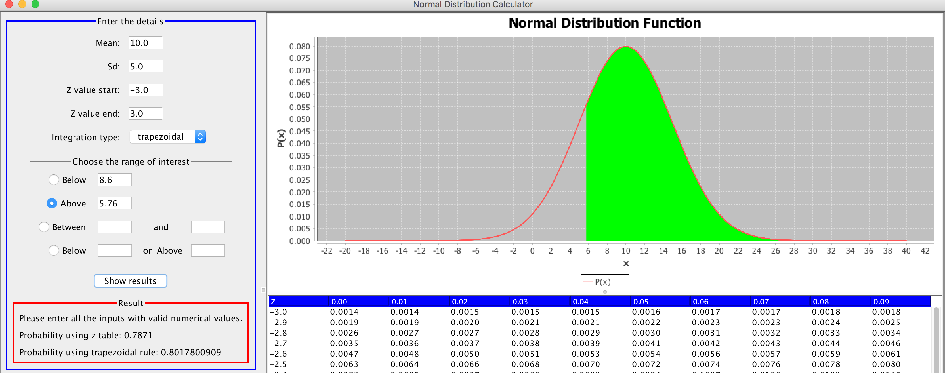

Figure 3: Between x1 and x2

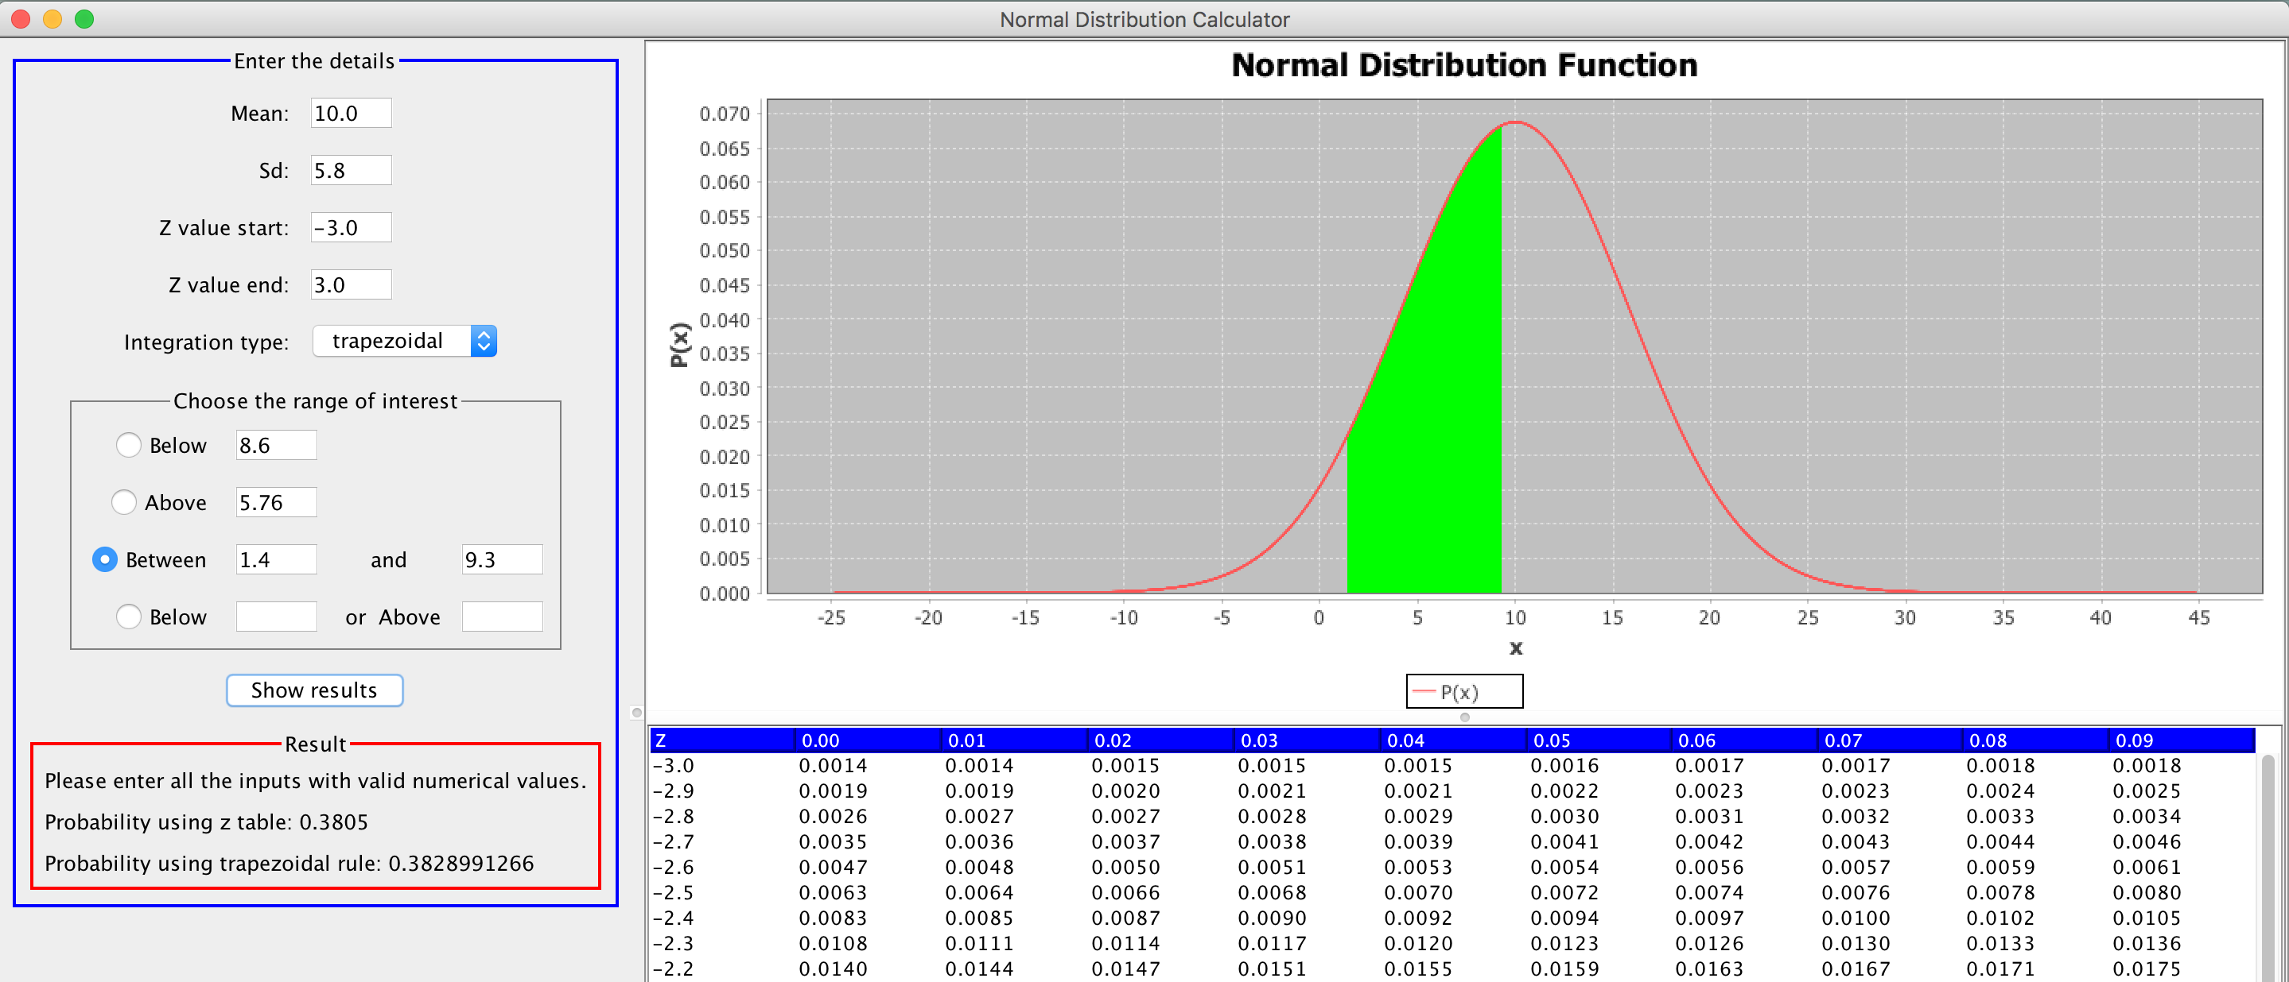

Figure 3: Below or Above x2

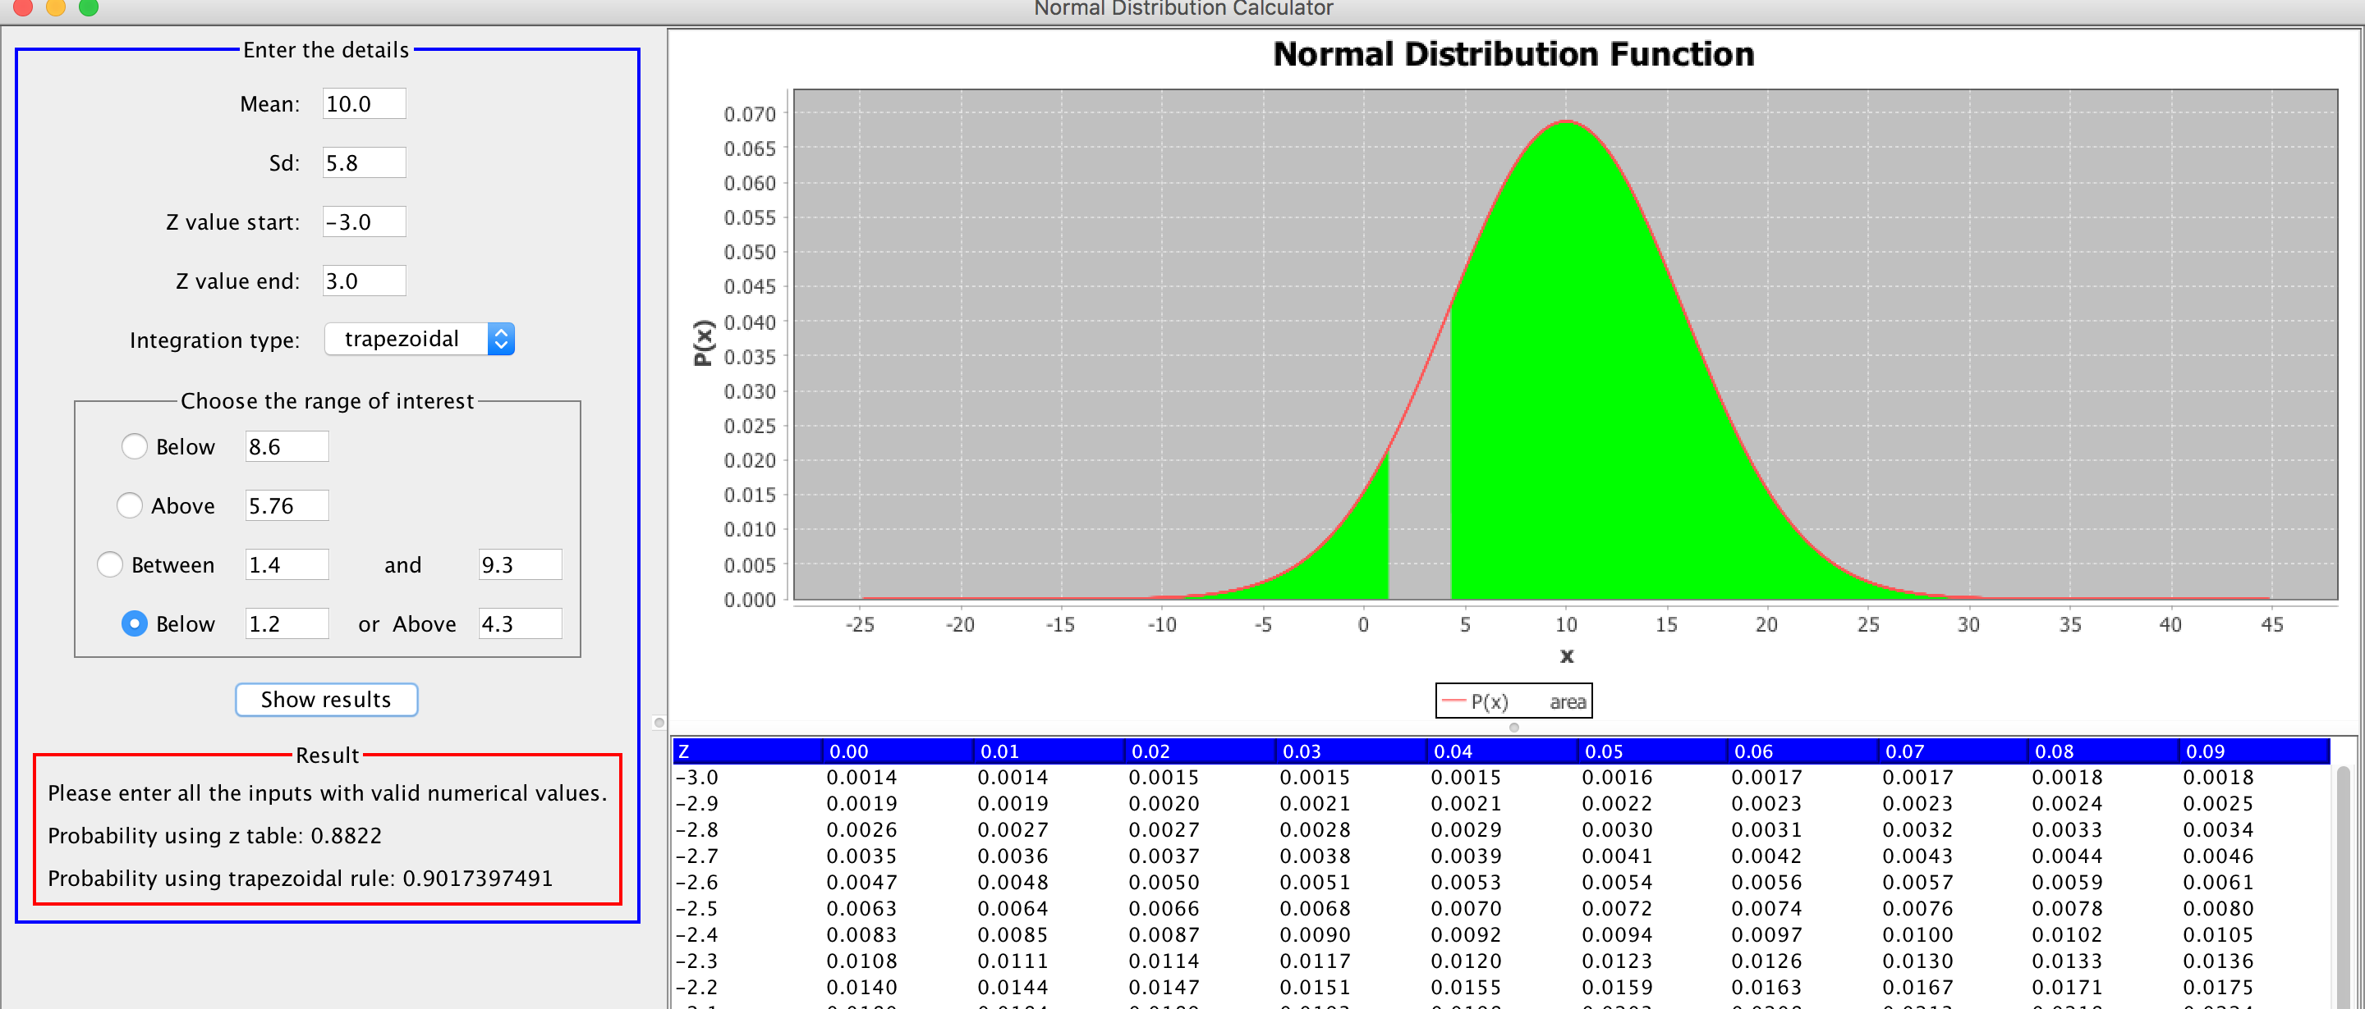

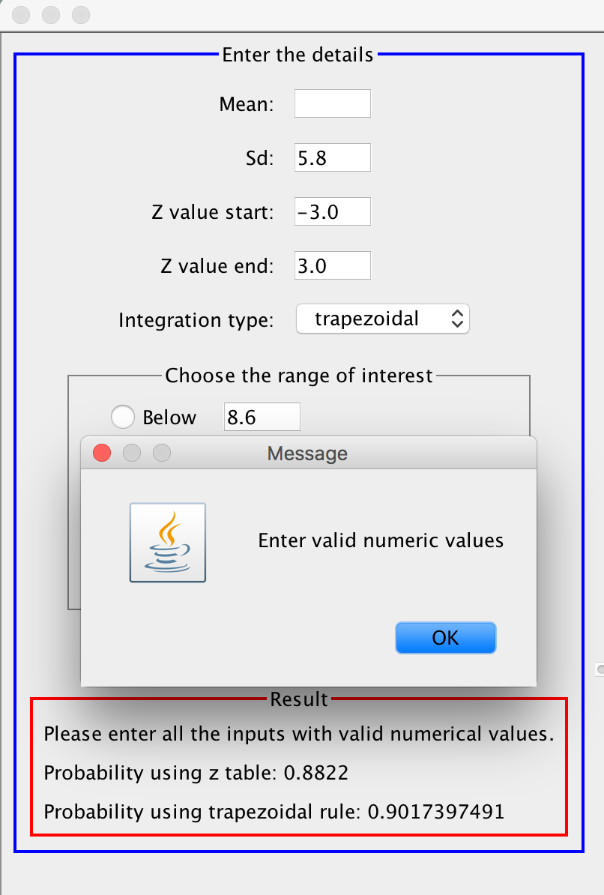

Any wrong inputs will be reported with error messages.

The z table can be generated by giving z table start and end

values.

# Testing

The application is tested using white box testing, as it is effective in finding errors. It can be also used to optimize the code. Before testing, the test cases and test data are designed. Since white box testing is implemented, the test data is designed by examining the code. All the if-else conditions and invalid inputs are tested to ensure the robustness of the application. In this section, the test cases are defined and the final result is mentioned. For complete testing table refer Appendix.

|  |  |  |  |  |  |
| --- | --- | --- | --- | --- | --- |
| Test case number | Test case | Subtest case | Requirement | Subtest case result | Result |
| 1 | Validating common inputs – mean, standard deviation, z table start and end values. | Not applicable. | Not applicable. | Not applicable | Success. |
| 2 | Below x1 | Validate x1  - Verify if x1 is a valid numerical value. | Test case 1 should be successful. | Success. | Success. |
| Calculating the probability and plotting the graph. | Validate x1 should be successful. | Success. |
| 3 | Above x1 | Validate x1  - Verify if x1 is a valid numerical value. | Test case 1 should be successful. | Success. | Success. |
| Calculating the probability and plotting the graph. | Validate x1 should be successful. | Success. |
| 4 | Between x1 and x2 | Validate x1 and x2  - Verify if x1 and x2 is a valid numerical value. | Test case 1 should be successful. | Success. | Success. |
| Calculating the probability and plotting the graph. | Validate x1 and x2 should be successful. | Success. |
| 5 | Below x1 or x2 | Validate x1 and x2  - Verify if x1 and x2 is a valid numerical value. | Test case 1 should be successful. | Success. | Success. |
| Calculating the probability and plotting the graph. | Validate x1 and x2 should be successful. | Success. |
| 6 | Displaying zTable  - display zTable according to the start and end values. | Not applicable | Test case 1 should be successful. | Not applicable | Success. |

# Evaluation of the data structure and algorithm

## Evaluation of the data structure

For generating the z table, a HashMap is used. The table is generated at the start of the application from -4.1 to +4.1 (below -4.1 all values are 0.0000 and above +4.1 all values are 1.0000). Generating the table once, will reduce the time to calculate the z values again. Each time, the user selects the z start and end, the rows will be searched from the stored table.

For the HashMap, the key is a double and the associated value is the entire row (array of string). Since the HashMap retrieves data using the unique key, the process becomes fast. Furthermore, each search operations will fetch the entire row. The row itself is an array hence, any value can be accessed randomly from it.

### Performance analysis of the data structure

**HashMap**

Time complexity to create the z table: O(n).

Whenever, the user enters the z table start and end values, the HashMap will fetch an entire row from the stored date.

When z table start and end values are equal, only one row has to be fetched. The time complexity in this scenario is O(1).

When z table start and end values are not equal, n rows has to be fetched. The time complexity in this case is O(n).

For calculating the probability, the time complexity would be O(1).

## Evaluation of the algorithm

The numerical integration methods used for this application are trapezoidal and Simpson rule. The trapezoidal rule can be used for even or odd subintervals. It is simpler to implement when compared to Simpson rule. However, it is not as accurate as Simpson rule with 0.8% absolute true error. In contrast, Simpson rule is more accurate with 0% absolute true error. However, it can be only implemented for even number of intervals.

### Performance analysis of the algorithm

Time complexity for calculating using trapezoidal rule is: O(n).

Time complexity for calculating using Simpson rule is: O(n).

# Appendix

## Testing Table

Test Case 1: Validating common inputs

|  |  |  |  |  |  |
| --- | --- | --- | --- | --- | --- |
| Serial no | Component being tested | Input | Expected output | Output | Result |
| 1 | Mean | 0.0 | A graph should be plotted, a zTable should be generated. The probability should be calculated and displayed. | A graph has been plotted, a zTable has been generated. The probability has been calculated and displayed. | Success |
| 2 | ab | An error message saying "Enter valid numeric values" should be displayed. | An error message saying "Enter valid numeric values" is displayed. | Success |
| 3 | -1.0 | A graph should be plotted, a zTable should be generated. The probability should be calculated and displayed. | A graph has been plotted, a zTable has been generated. The probability has been calculated and displayed. | Success |
| 4 | Standard deviation | ab | An error message saying "Enter valid numeric values" should be displayed. | An error message saying "Enter valid numeric values" is displayed. | Success |
| 5 | 0.0 | An error message saying "Standard deviation should be greater than zero" should be displayed. | An error message saying " Standard deviation should be greater than zero " is displayed. | Success |
| 6 | -1.0 | An error message saying "Standard deviation should be greater than zero" should be displayed. | An error message saying "Enter valid numeric values" is displayed. | Success |
| 7 | 1.0 | A graph should be plotted, a zTable should be generated. The probability should be calculated and displayed. | A graph has been plotted, a zTable has been generated. The probability has been calculated and displayed. | Success |
| 8 | Z value start | -4.2 | An error message saying "Z values can be only between -4.1 to +4.1 " should be displayed. | An error message saying "Z values can be only between -4.1 to +4.1 " is displayed. | Success |
| 9 | ab | An error message saying "Enter valid numeric values" should be displayed. | An error message saying "Enter valid numeric values" is displayed. | Success |
| 10 | Greater than z end value | An error message saying " Z start value should be less than or equal to end value" should be displayed. | An error message saying " Z start value should be less than or equal to end value " is displayed. | Success |
| 11 | -4.1 | A graph should be plotted, a zTable starting at -4.1 should be generated. The probability should be calculated and displayed. | A graph has been plotted, a zTable starting at -4.1 has been generated. The probability has been calculated and displayed. | Success |
| 12 | Z value end | 4.2 | An error message saying "Z values can be only between -4.1 to +4.1 " should be displayed. | An error message saying " Standard deviation should be greater than zero " is displayed. | Success |
| 13 | ab | An error message saying "Enter valid numeric values" should be displayed. | An error message saying "Enter valid numeric values" is displayed. | Success |
| 14 | Less than z start value | An error message saying " Z start value should be less than or equal to end value" should be displayed. | An error message saying " Z start value should be less than or equal to end value " is displayed. | Success |
| 15 | 4.1 | A graph should be plotted, a zTable ending at -4.1 should be generated. The probability should be calculated and displayed. | A graph has been plotted, a zTable starting at -4.1 has been generated. The probability has been calculated and displayed. | Success |

Test Case 2.1: Validating x1

|  |  |  |  |  |  |
| --- | --- | --- | --- | --- | --- |
| Serial no | Component being tested | Input | Expected output | Output | Result |
| 1 | Below x1 text field | ab | An error message saying "Enter valid numeric values" should be displayed. | An error message saying "Enter valid numeric values" is displayed. | Success |
| 2 | 1.0 | A graph should be plotted, a zTable should be generated. The probability should be calculated and displayed. | A graph has been plotted, a zTable has been generated. The probability has been calculated and displayed. | Success |

## 

Test Case 2.2: Calculating the probability and plotting the graph

|  |  |  |  |  |  |
| --- | --- | --- | --- | --- | --- |
| Serial number | Component being tested | Input | Expected output | Output | Result |
| 1 | Below x1 | Mean: 0.0  Sd: 1.0  X1: 1  Integration method: trapezoidal | Probability using zTable: 0.8413  Probability using trapezoidal rule: 0.84134475  A graph with shaded area below 1.0 should be displayed. | Probability using zTable: 0.8245  Probability using trapezoidal rule: 0.8413437570.  A graph with shaded area below 1.0 is displayed. | Success. |
| 2 | Mean:  -1.0  Sd: 2.0  X1: -3  Integration method: trapezoidal | Probability using zTable: 0.1589  Probability using trapezoidal rule: 0.15865525  A graph with shaded area below -3.0 should be displayed. | Probability using zTable: 0.1595  Probability using trapezoidal rule: 0.15865571  A graph with shaded area below -3.0 is displayed. | Success. |
| 3 | Mean:  100  Sd: 50  X1: 30  Integration method: trapezoidal | Probability using zTable: 0.0812  Probability using trapezoidal rule: 0.08075666  A graph with shaded area below 30 should be displayed. | Probability using zTable: 0.0812  Probability using trapezoidal rule: 0.080757029  A graph with shaded area below 30 is displayed. | Success |
| 4 | Mean: 0.0  Sd: 1.0  X1: 1  Integration method: Simpson | Probability using zTable: 0.8413  Probability using Simpson rule: 0.839666  A graph with shaded area below 1.0 should be displayed. | Probability using zTable: 0.8425.  Probability using Simpson rule: 0.8424739418.  A graph with shaded area below 1.0 is displayed. | Success. |
| 5 | Mean:  -1.0  Sd: 2.0  X1: -3  Integration method: Simpson | Probability using zTable: 0.1589  Probability using Simpson rule: 0.15865525  A graph with shaded area below -3.0 should be displayed. | Probability using zTable: 0.1595  Probability using Simpson rule: 0.159461820  A graph with shaded area below -3.0 is displayed. | Success. |
| 6 | Mean:  100  Sd: 50  X1: 30  Integration method: Simpson | Probability using zTable: 0.0812  Probability using Simpson rule: 0.0812156  A graph with shaded area below 30 should be displayed. | Probability using zTable: 0.0812  Probability using Simpson rule: 0.0812158225  A graph with shaded area below 30 is displayed | Success. |

Test Case 3.1: Validating x1

|  |  |  |  |  |  |
| --- | --- | --- | --- | --- | --- |
| Serial | Component being tested | Input | Expected output | Output | Result |
| 1 | Above x1 text field | ab | An error message saying "Enter valid numeric values" should be displayed. | An error message saying "Enter valid numeric values" is displayed. | Success. |
| 2 | 1.0 | A graph should be plotted, a zTable should be generated. The probability should be calculated and displayed. | A graph has been plotted, a zTable has been generated. The probability has been calculated and displayed. | Success. |

Test Case 3.2: Calculating the probability and plotting the graph

|  |  |  |  |  |  |
| --- | --- | --- | --- | --- | --- |
| Serial number | Component being tested | Input | Expected output | Output | Result |
| 1 | Above x1 text field | Mean: 0.0  Sd: 1.0  X1: 1  Integration method: trapezoidal | Probability using zTable: 0.1587  Probability using trapezoidal rule: 0.15865525.  A graph with shaded area above 1.0 should be displayed. | Probability using zTable: 0.1575  Probability using trapezoidal rule: 0.158655751.  A graph with shaded area above 1.0 is displayed. | Success. |
| 2 | Mean:  -1.0  Sd: 2.0  X1: -3  Integration method: trapezoidal | Probability using zTable: 0.8411  Probability using trapezoidal rule: 0.84134475  A graph with shaded area above -3.0 should be displayed. | Probability using zTable: 0.8405  Probability using trapezoidal rule: 0.841343757570  A graph with shaded area above 1.0 is displayed. | Success. |
| 3 | Mean:  100  Sd: 50  X1: 30  Integration method: trapezoidal | Probability using zTable: 0.9188  Probability using trapezoidal rule: 0.91924334.  A graph with shaded area above 30 should be displayed. | Probability using zTable: 0.9188  Probability using trapezoidal rule: 0.9192423832  A graph with shaded area above 30 is displayed. | Success. |
| 4 | Mean: 0.0  Sd: 1.0  X1: 1  Integration method: Simpson | Probability using zTable: 0.1587  Probability using Simpson rule: 0.160334  A graph with shaded area above 1.0 should be displayed. | Probability using zTable: 0.1575  Probability using Simpson rule: 0.1586552530.  A graph with shaded area above 1.0 is displayed. | Success. |
| 5 | Mean:  -1.0  Sd: 2.0  X1: -3  Integration method: Simpson | Probability using zTable: 0.8411  Probability using Simpson rule: 0.84134475  A graph with shaded area above -3.0 should be displayed. | Probability using zTable: 0.8405  Probability using Simpson rule: 0.8413447451  A graph with shaded area above 1.0 is displayed. | Success. |
| 6 | Mean:  100  Sd: 50  X1: 30  Integration method: Simpson | Probability using zTable: 0.9188  Probability using Simpson rule: 0.9187844.  A graph with shaded area above 30 should be displayed. | Probability using zTable: 0.9188  Probability using Simpson rule: 0.9192433398  A graph with shaded area above 30 is displayed. | Success. |

Test Case 4.1: Validating x1 and x2

|  |  |  |  |  |  |
| --- | --- | --- | --- | --- | --- |
| Serial | Component being tested | Input | Expected output | Output | Result |
| 1 | x1 text field | ab | An error message saying "Enter valid numeric values" should be displayed. | An error message saying "Enter valid numeric values" is displayed. | Success. |
| 2 | 1.0 | A graph should be plotted, a zTable should be generated. The probability should be calculated and displayed. | A graph has been plotted, a zTable has been generated. The probability has been calculated and displayed. | Success. |
| 3 | x2 text field | ab | An error message saying "Enter valid numeric values" should be displayed. | An error message saying "Enter valid numeric values" is displayed. | Success. |
| 4 | 1.0 | A graph should be plotted, a zTable should be generated. The probability should be calculated and displayed. | A graph has been plotted, a zTable has been generated. The probability has been calculated and displayed. | Success. |

Test Case 4.2: Calculating the probability and plotting the graph

|  |  |  |  |  |  |
| --- | --- | --- | --- | --- | --- |
| Serial number | Component being tested | Input | Expected output | Output | Result |
| 1 | x1 and x2 | Mean: 0.0  Sd: 1.0  X1: 1.0  X2: 2.0  Integration method: trapezoidal | Probability using zTable: 0.1359  Probability using trapezoidal rule: 0.13590512.  A graph with shaded area between 1.0 and 2.0 should be displayed. | Probability using zTable: 0.1359  Probability using trapezoidal rule: 0.1359051331.  A graph with shaded area between 1.0 and 2.0 is displayed. | Success. |
| 2 | Mean:  -1.0  Sd: 2.0  X1: -3.0  X2: -2.0  Integration method: trapezoidal | Probability using zTable: 0.1500  Probability using trapezoidal rule: 0.14988228  A graph with shaded area between -3.0 and -2.0 should be displayed. | Probability using zTable: 0.1503  Probability using trapezoidal rule: 0.1498822834  A graph with shaded area between -3.0 and -2.0 is displayed. | Success. |
| 3 | Mean:  100  Sd: 50  X1: 30  X2: 30  Integration method: trapezoidal | Probability using zTable: 0.0000  Probability using trapezoidal rule: 0.00000000  A graph with no shaded region should be created. | Probability using zTable: 0.0000  Probability using trapezoidal rule: 0.0000000000  A graph with no shaded region is created. | Success. |
| 4 | Mean: 0.0  Sd: 1.0  X1: 1.0  X2: 2.0  Integration method: Simpson | Probability using zTable: 0.1359  Probability using Simpson rule: 0.13590512  A graph with shaded area between 1.0 and 2.0 should be displayed. | Probability using zTable: 0.1359  Probability using Simpson rule: 0.1359411160.  A graph with shaded area between 1.0 and 2.0 is displayed. | Success. |
| 5 | Mean:  -1.0  Sd: 2.0  X1: -3.0  X2: -2.0  Integration method: Simpson | Probability using zTable: 0.1500  Probability using Simpson rule: 0.14988228  A graph with shaded area between -3.0 and -2.0 should be displayed. | Probability using zTable: 0.1503  Probability using Simpson rule: 0.1499996399  A graph with shaded area between -3.0 and -2.0 is displayed. | Success. |
| 6 | Mean:  100  Sd: 50  X1: 30  X2: 30  Integration method: Simpson | Probability using zTable: 0.0000  Probability using Simpson rule: 0.00000000  A graph with no shaded region should be created. | Probability using zTable: 0.0000  Probability using Simpson rule: 0.0000000000  A graph with no shaded region is created. | Success. |

Test Case 5.1: Validating x1 and x2

|  |  |  |  |  |  |
| --- | --- | --- | --- | --- | --- |
| Serial | Component being tested | Input | Expected output | Output | Result |
| 1 | x1 text field | ab | An error message saying "Enter valid numeric values" should be displayed. | An error message saying "Enter valid numeric values" is displayed. | Success. |
| 2 | 1.0 | A graph should be plotted, a zTable should be generated. The probability should be calculated and displayed. | A graph has been plotted, a zTable has been generated. The probability has been calculated and displayed. | Success. |
| 3 | Value greater than x2 | An error message saying " Start value should be less than end value." should be displayed. | An error message saying " Start value should be less than end value." is displayed. | Success. |
| 4 | x2 text field | ab | An error message saying "Enter valid numeric values" should be displayed. | An error message saying "Enter valid numeric values" is displayed. | Success. |
| 5 | 1.0 | A graph should be plotted, a zTable should be generated. The probability should be calculated and displayed. | A graph has been plotted, a zTable has been generated. The probability has been calculated and displayed. | Success. |
| 6 | Value equal to x1 | An error message saying " Start value should be less than end value." should be displayed. | An error message saying " Start value should be less than end value." is displayed. | Success. |

Test Case 5.2: Calculating the probability and plotting the graph

|  |  |  |  |  |  |
| --- | --- | --- | --- | --- | --- |
| Serial number | Component being tested | Input | Expected output | Output | Result |
| 1 | x1 and x2 | Mean: 0.0  Sd: 1.0  X1: 1.0  X2: 2.0  Integration method: trapezoidal | Probability using zTable: 0.8641  Probability using trapezoidal rule: 0.86409488.  A graph with shaded area below 1.0 and above 2.0 should be displayed. | Probability using zTable: 0.8650  Probability using trapezoidal rule: 0.8640948669.  A graph with shaded area below 1.0 and above 2.0 is displayed. | Success. |
| 2 | Mean:  -1.0  Sd: 2.0  X1: -3.0  X2: -2.0  Integration method: trapezoidal | Probability using zTable: 0.8500  Probability using trapezoidal rule: 0.85011772  A graph with shaded area below -3.0 and above -2.0 should be displayed. | Probability using zTable: 0.8497  Probability using trapezoidal rule: 0.8501177166  A graph with shaded area below -3.0 and above -2.0 is displayed. | Success. |
| 3 | Mean:  100.0  Sd: 50.0  X1: 29.78  X2: 30  Integration method: trapezoidal | Probability using zTable: 1.0000  Probability using trapezoidal rule: 0.99934323  A completely shaded graph should be created. | Probability using zTable: 1.0000  Probability using trapezoidal rule: 0.9993432262  A completely shaded graph is created. | Success. |
| 4 | Mean: 0.0  Sd: 1.0  X1: 1.0  X2: 2.0  Integration method: Simpson | Probability using zTable: 0.8641  Probability using Simpson rule: 0.86409488.  A graph with shaded area below 1.0 and above 2.0 should be displayed. | Probability using zTable: 0.8650  Probability using Simpson rule: 0.8640948669.  A graph with shaded area below 1.0 and above 2.0 is displayed. | Success. |
| 5 | Mean:  -1.0  Sd: 2.0  X1: -3.0  X2: -2.0  Integration method: Simpson | Probability using zTable: 0.8500  Probability using Simpson rule: 0.85011772  A graph with shaded area below -3.0 and above -2.0 should be displayed. | Probability using zTable: 0.8497  Probability using Simpson rule: 0.8500003601  A graph with shaded area below -3.0 and above -2.0 is displayed. | Success. |
| 6 | Mean:  100.0  Sd: 50.0  X1: 29.78  X2: 30  Integration method: Simpson | Probability using zTable: 1.0000  Probability using Simpson rule: 0.99934323  A completely shaded graph should be created. | Probability using zTable: 1.0000  Probability using Simpson rule: 0.99934278770  A completely shaded graph is created. | Success. |

Test Case 6: Displaying zTable

|  |  |  |  |  |  |
| --- | --- | --- | --- | --- | --- |
| Serial no | Component being tested | Input | Expected output | Output | Result |
| 1 | zTable start value and end value. | Z value start: -3.0  Z value start: 1.0 | A table starting at -3.0 and ending at 1.0 has to be displayed. | A table starting at -3.0 and ending at 1.0 is displayed. | Success |
| 2 | Z value start: 1.2  Z value start: 3.3 | A table starting at 1.2 and ending at 3.3 has to be displayed. | A table starting at 1.2 and ending at 3.3 is displayed. | Success |